Data Analysis Manual

Contents

Exploratory Data Wrangling And Analysis 2

Simple Understanding Of Data Using Pivot Tables 2

Queries Using Vlookup And IF Formulas 7

Vlookup 7

IF Formula 9

Check for Firms Missing In Action Using Pivot Tables 10

Final Touches 11

Sorting 11

Export 11

Storage 11

Data Organization & Arranging Using Tables 12

# Exploratory Data Wrangling And Analysis

### Simple Understanding Of Data Using Pivot Tables

1. open merged excel file
2. open data spreadsheet
3. Rename Sheet 1 to “Data”
4. Delete the first column with index numbers

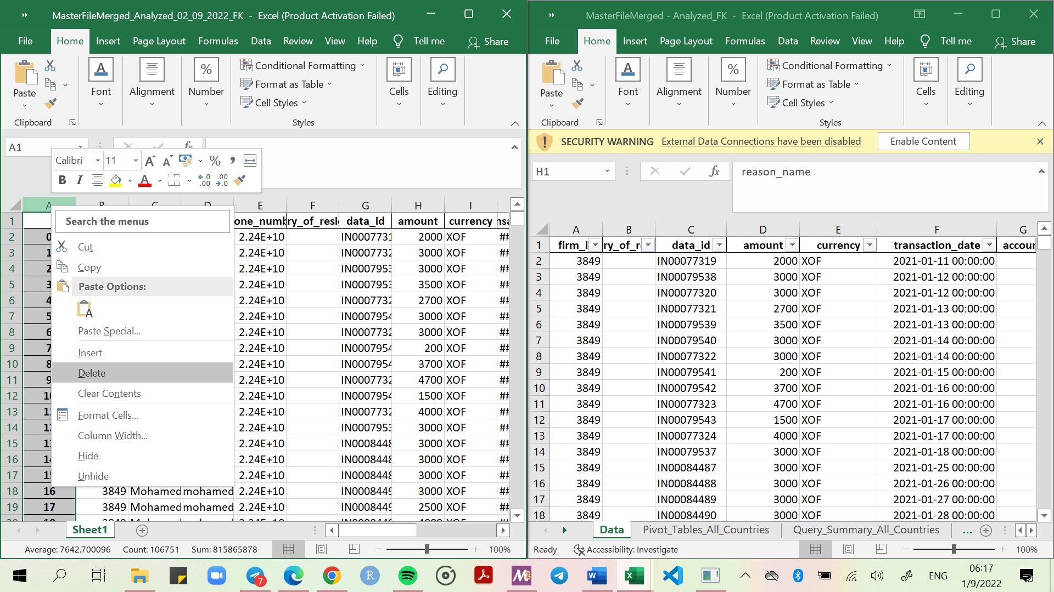

1. Find the phone number column and set its format to *Number*
2. select all of the data, click insert (next to home) and create a pivot table in a new sheet as shown below. Click OK.
3. Rename Sheet 2, that contains the pivot table to Pivot_Tables_All_Countries

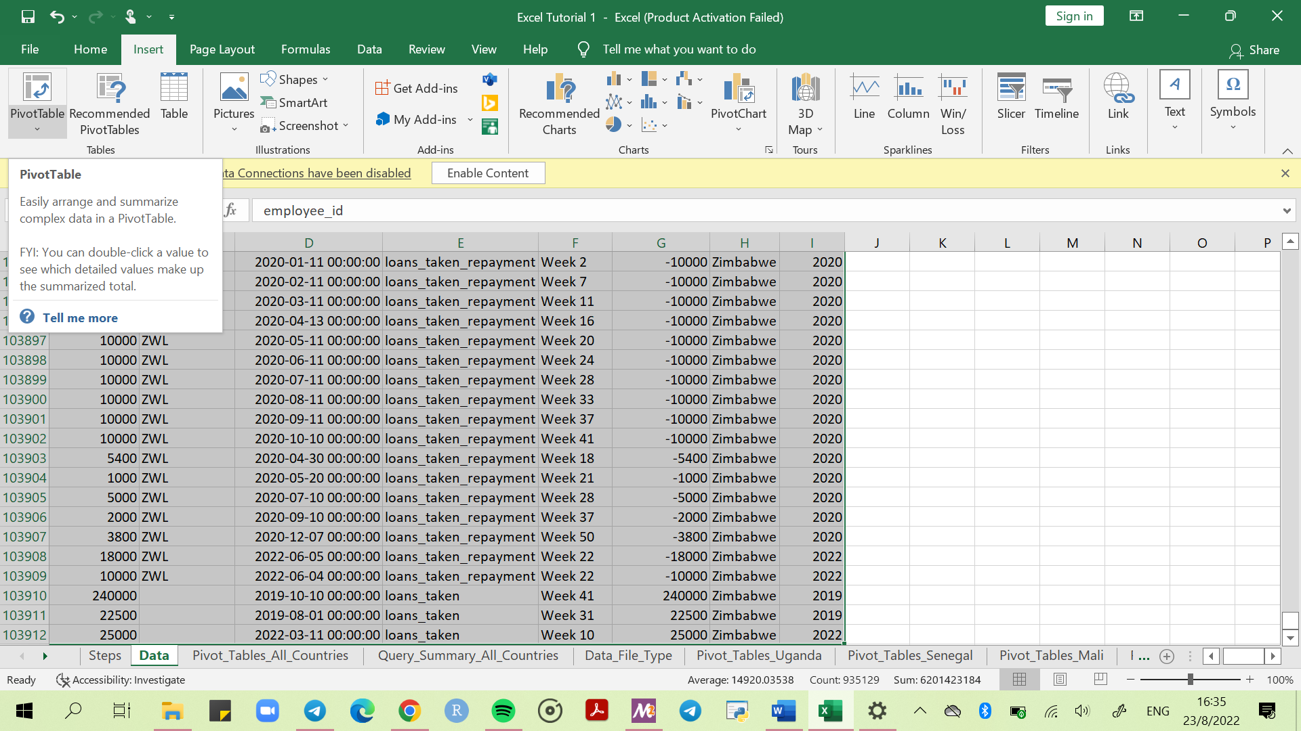

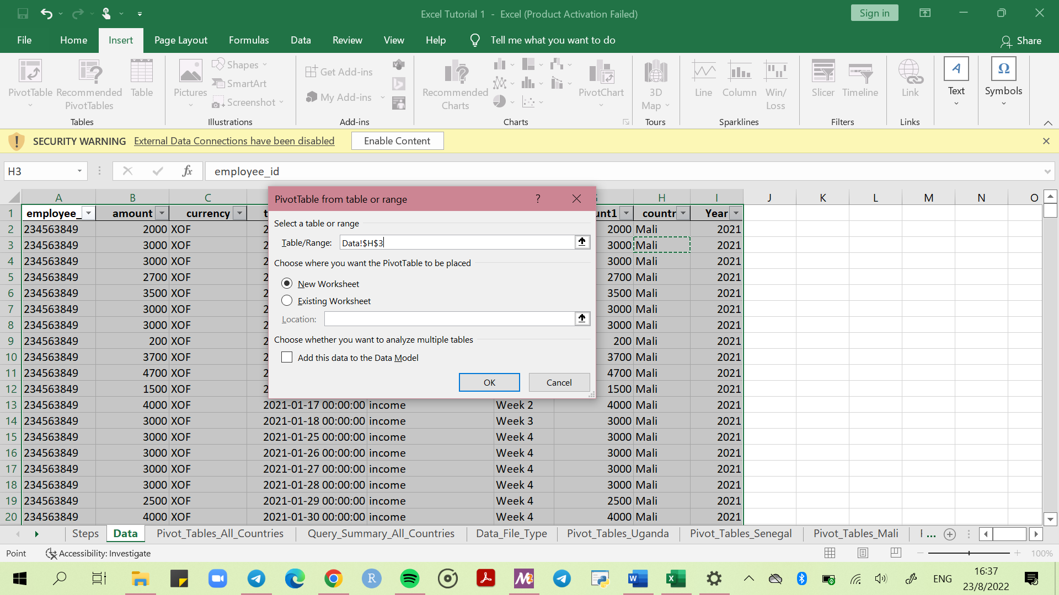

1. A blank pivot table will appear as shown below.

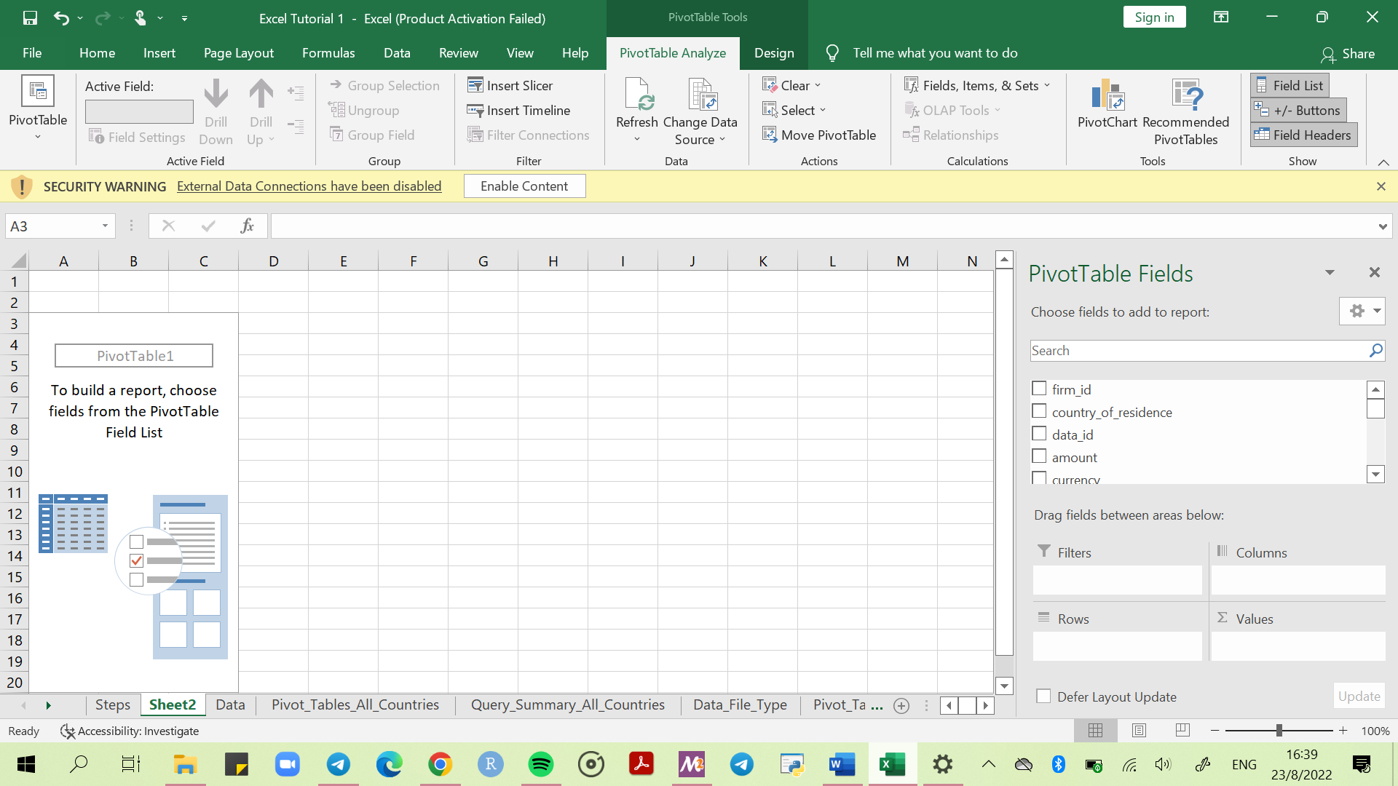

1. Under Pivot Table Fields on the far-right side, use the following settings. (*Feel free to adjust settings as needed, depending on the type of analysis*. Refer to the image below.
2. **Filters** – what you want to filter the data with. **Recommended: *Year, Account, Country***
3. **Columns** – what you want in the columns. **Recommended: *week***
4. **Rows** – what you want in the rows, using the unique identity number. **Recommended:** ***firm_id***
5. **Values** – what you want calculated. **Recommended:** ***Amount***that will show as***Sum of Amount***

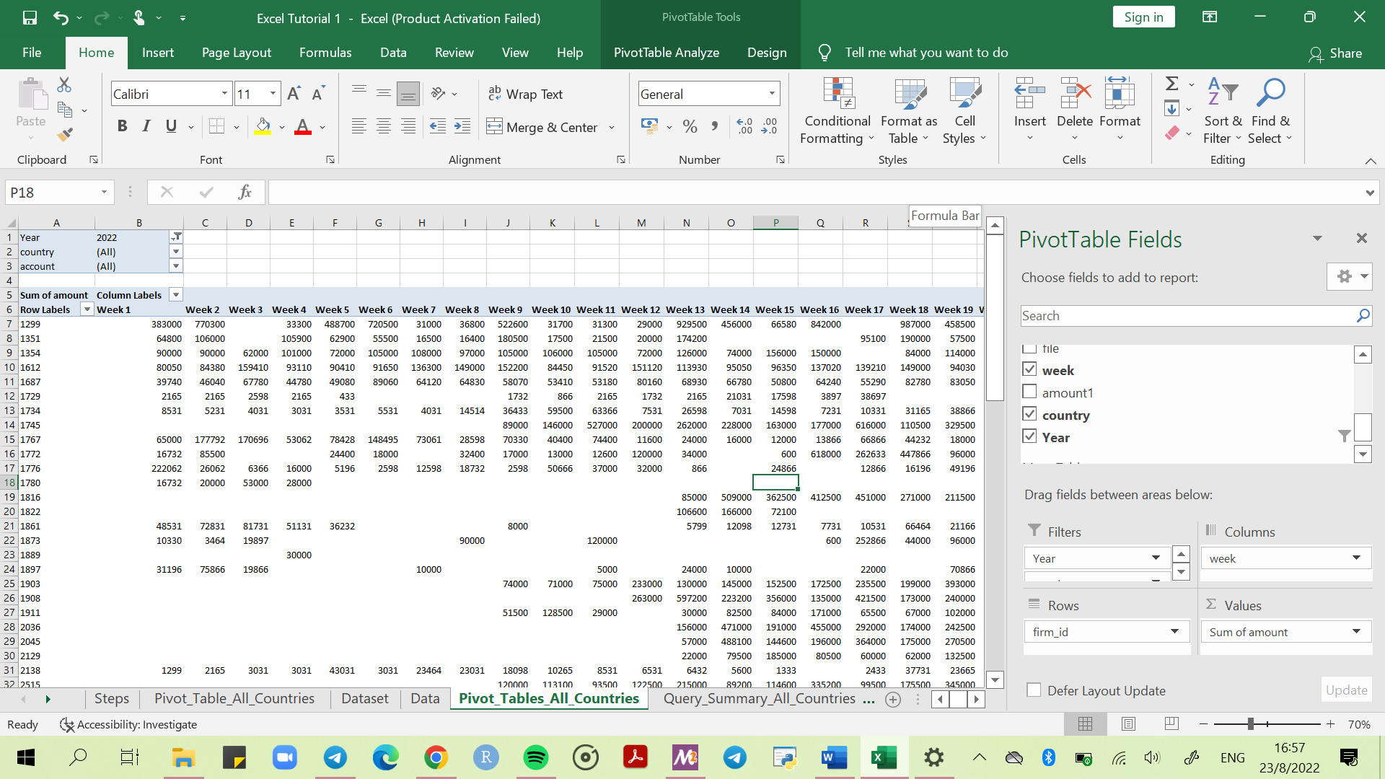

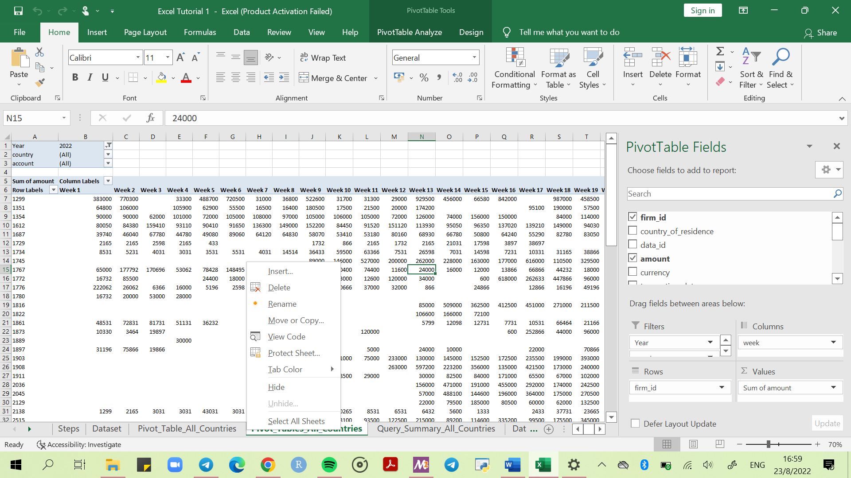

1. At the top left corner of the pivot table, Select the *Year* filter. Click *Select Multiple Items* and them select the desired year. **Recommended Year: 2022.**

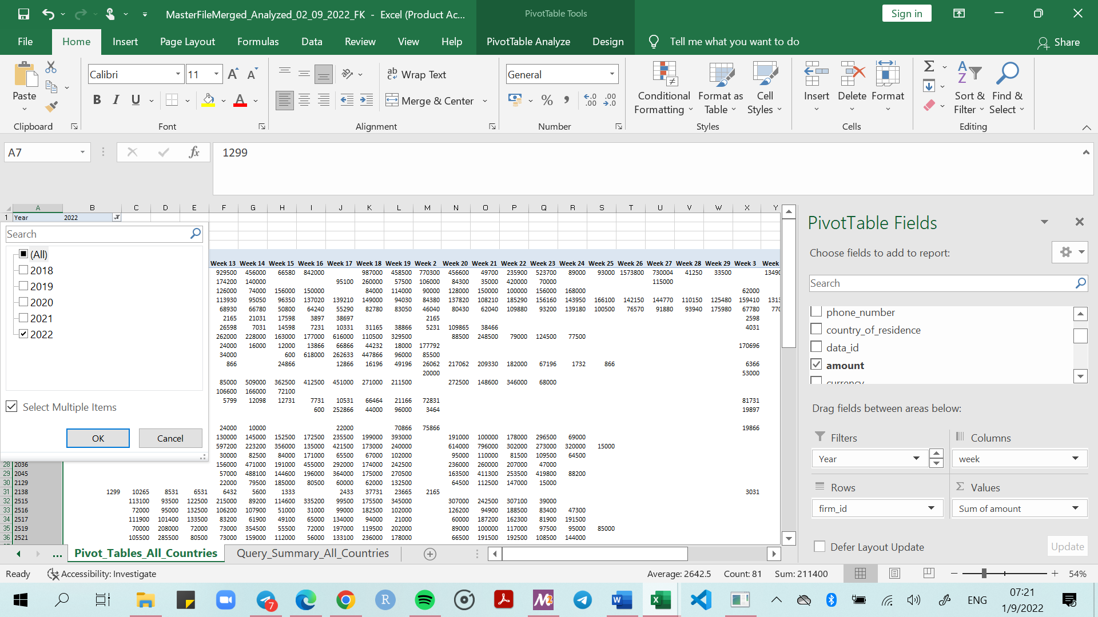

Note that columns will be in random order. Arrange the pivot table columns manually in chronological order.

1. Create separate pivot tables for each country by using the filter if needed. Separate pivot tables will make comparison at a glance a lot easier. Refer to images below.

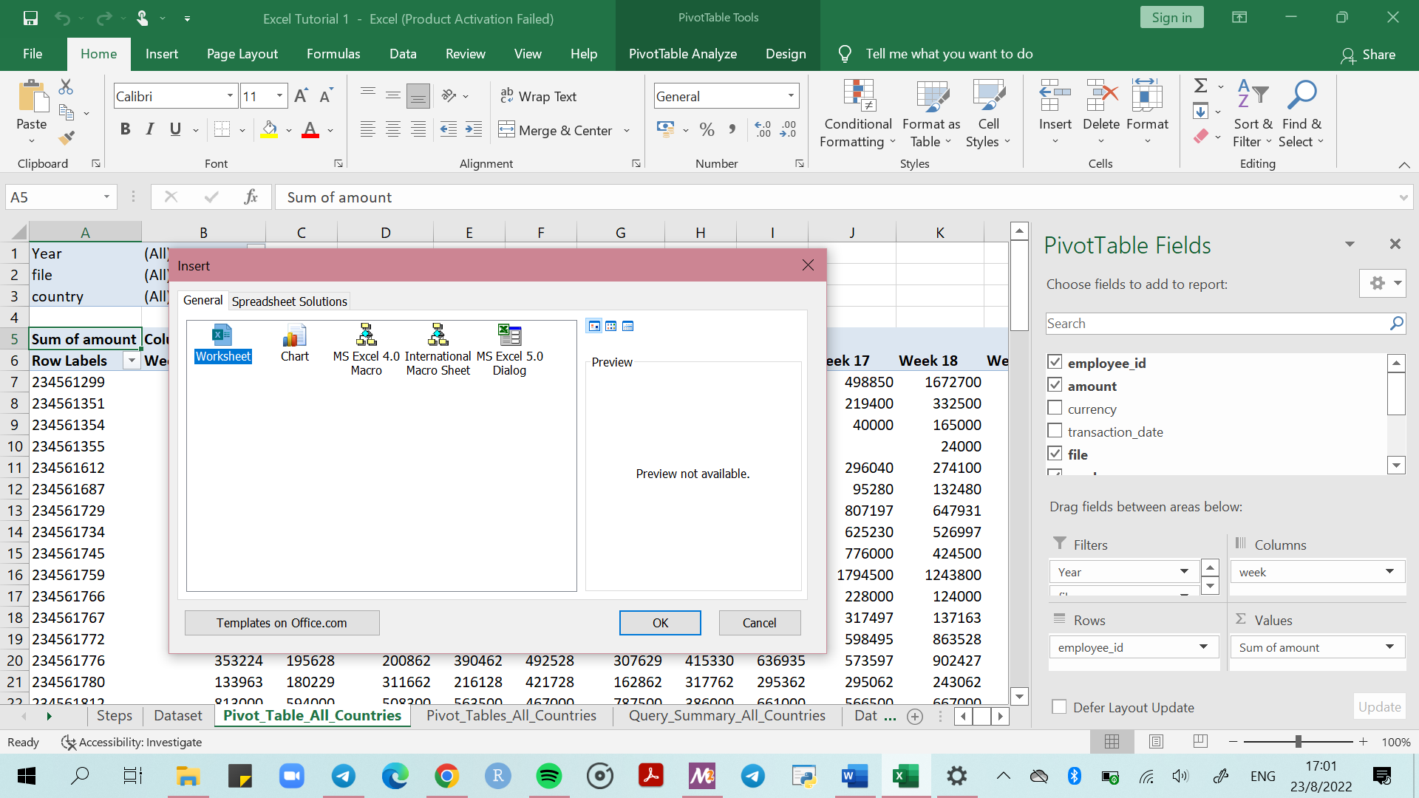

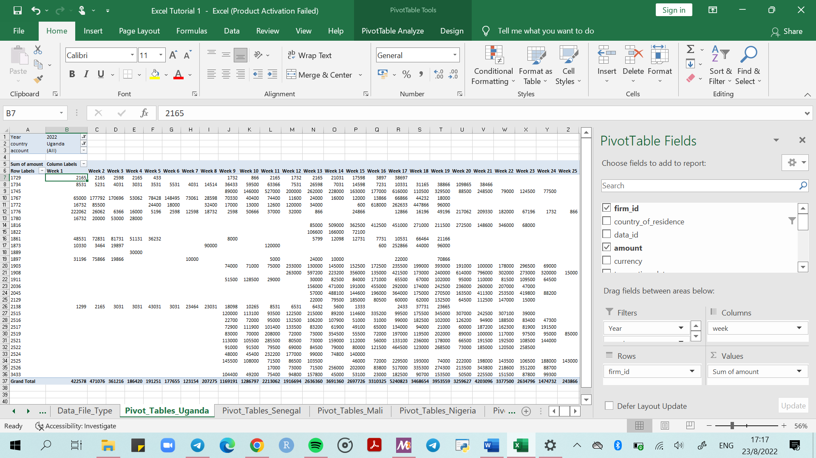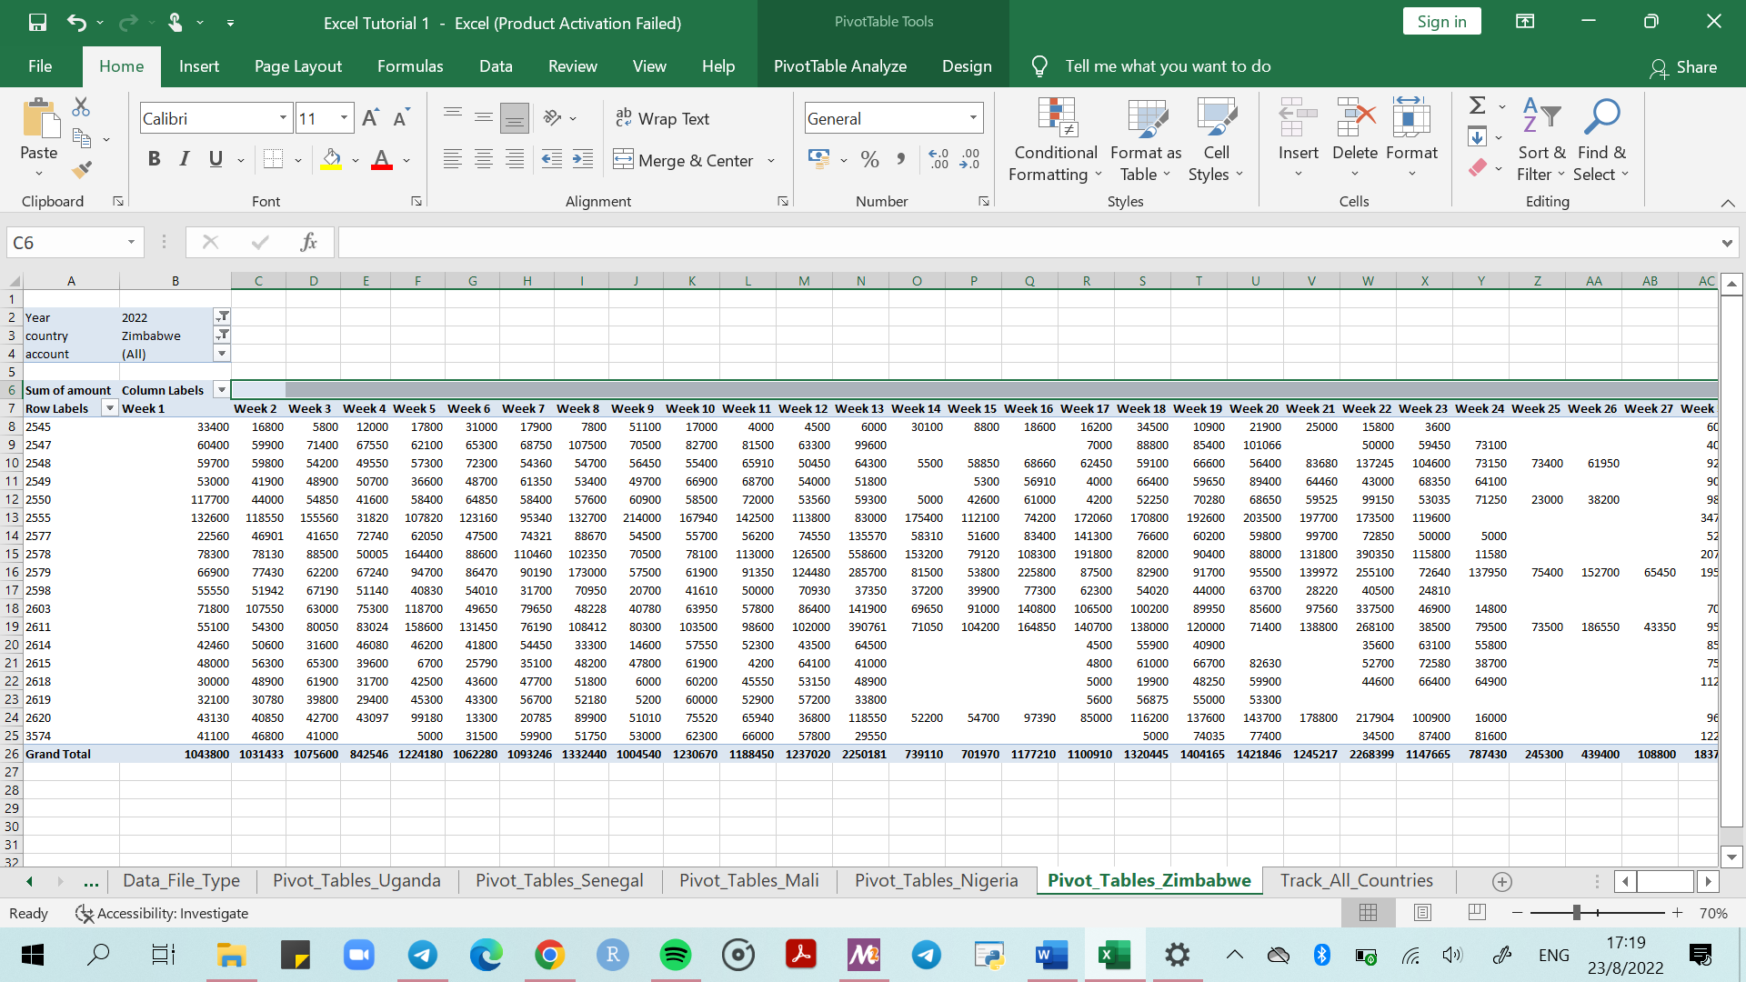

# Queries Using Vlookup And IF Formulas

### Vlookup

*Remember to lock the array tables with $*

1. Highlight all firm-id’s from top to bottom, copy and paste as values into newly created spreadsheet *Query_Summary_All_Countries*

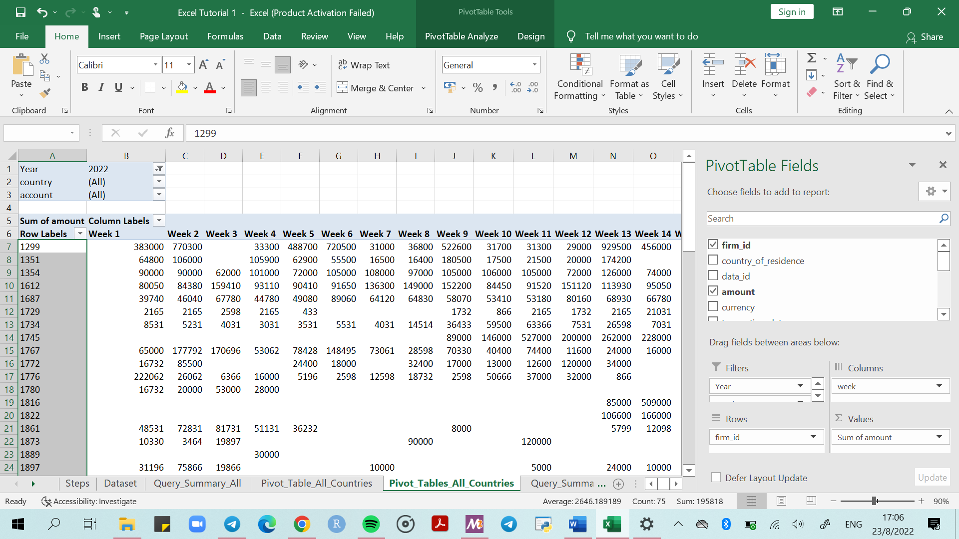

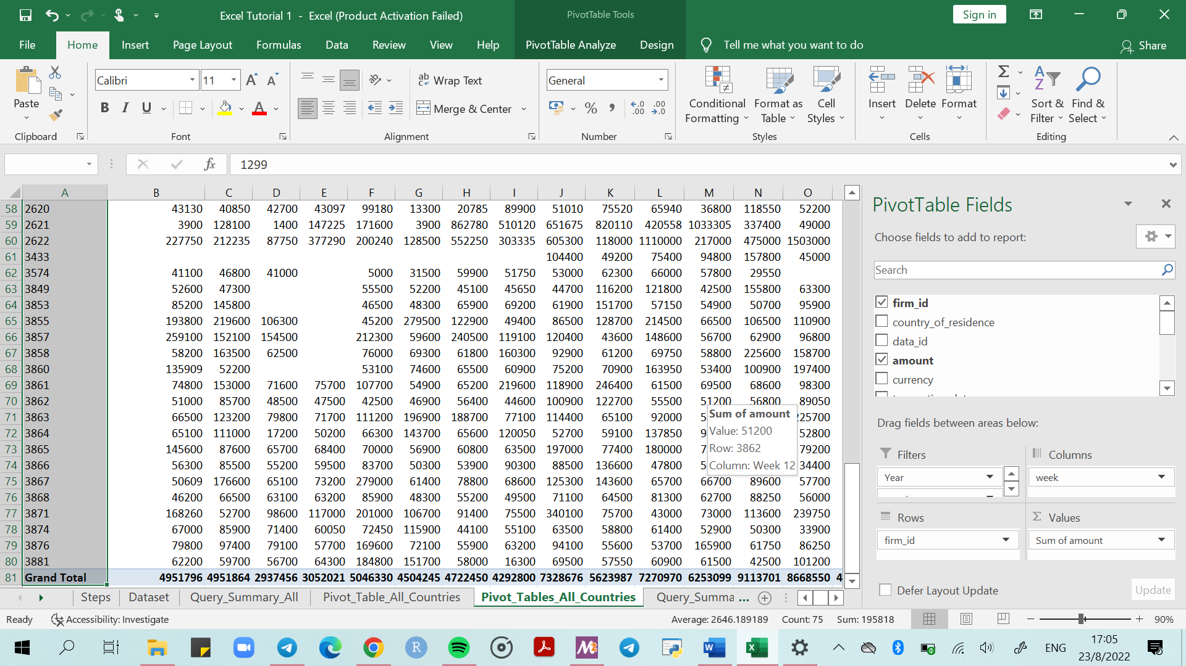

1. Create a new sheet by right clicking next to an existing excel spreadsheet. Click insert, select worksheet on the dialog that appears, click ok. Rename the new spreadsheet to “*Query_Summary_All_Countries*”.
2. Paste the firm id’s onto a new spreadsheet: “*Query_Summary_All_Countries*”. Paste as values.

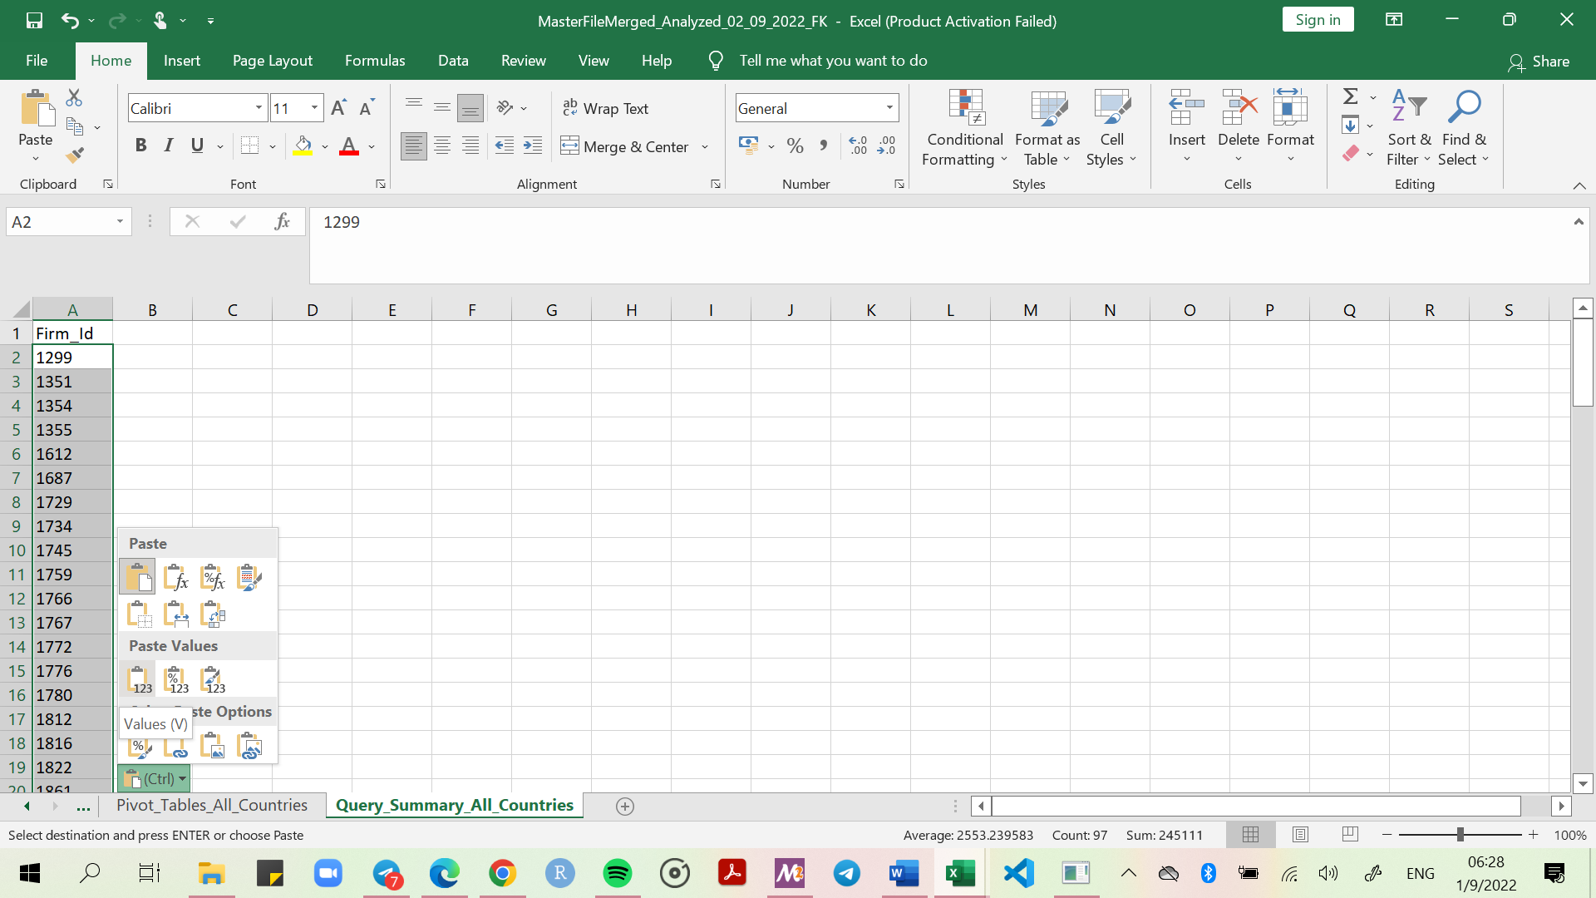

1. Create a new column country and use the vlookup formula to extract the respective country of each firm using the firm id as reference. And the Data Spreadsheet as the source. Use the fill handle command. See below

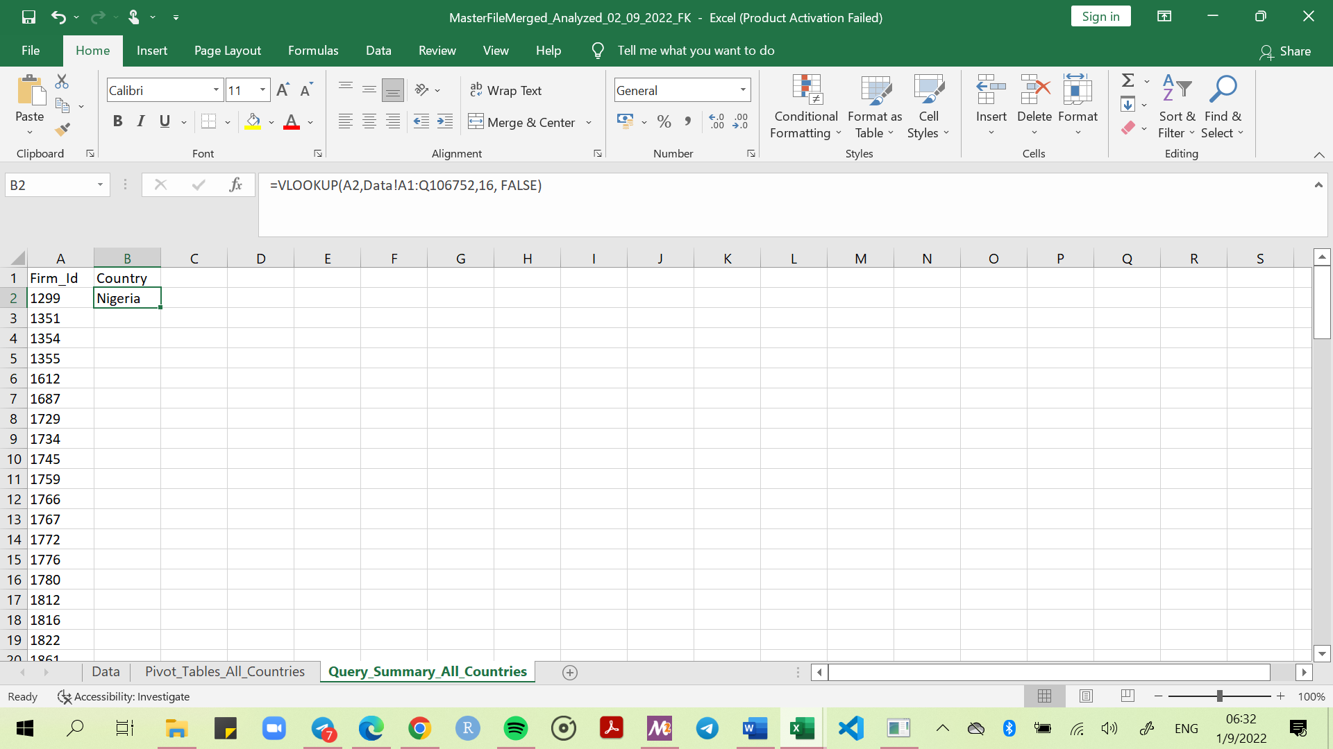

1. Do the same for Name, Email and Phone Number. Copy each column and paste as values to avoid errors in the future.

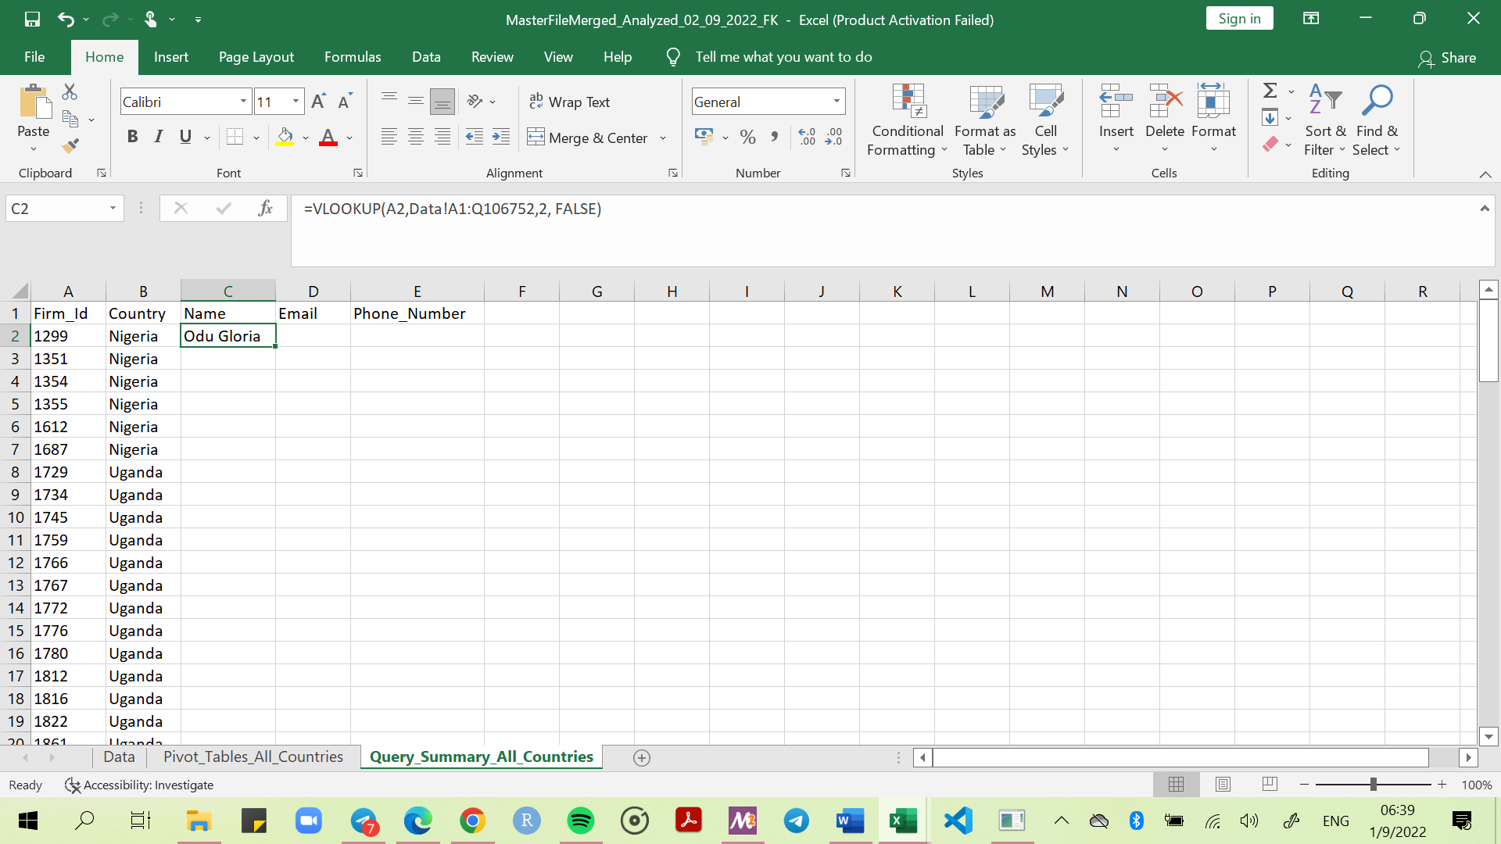

1. For email use:

***=IF(LEN(VLOOKUP(A2,Data!$A$1:$Q$106752,3,FALSE))=0,"No Email",VLOOKUP(A2,Data!$A$1:$Q$106752,3,FALSE))***

1. For phone number, use the following:

***=IF(LEN(VLOOKUP(A2,Data!$A$1:$Q$106752,4,FALSE))=0,"No Phone Number",VLOOKUP(A2,Data!$A$1:$Q$106752,4,FALSE))***

### IF Formula

1. Create a new column and name it *Number_of_Empty_Cells(weeks)*. Use the **IF** and **COUNTBLANK** Formula to count the number of weeks/cells that are empty in the pivot table. Use the fill handle formula for the rest. See below.

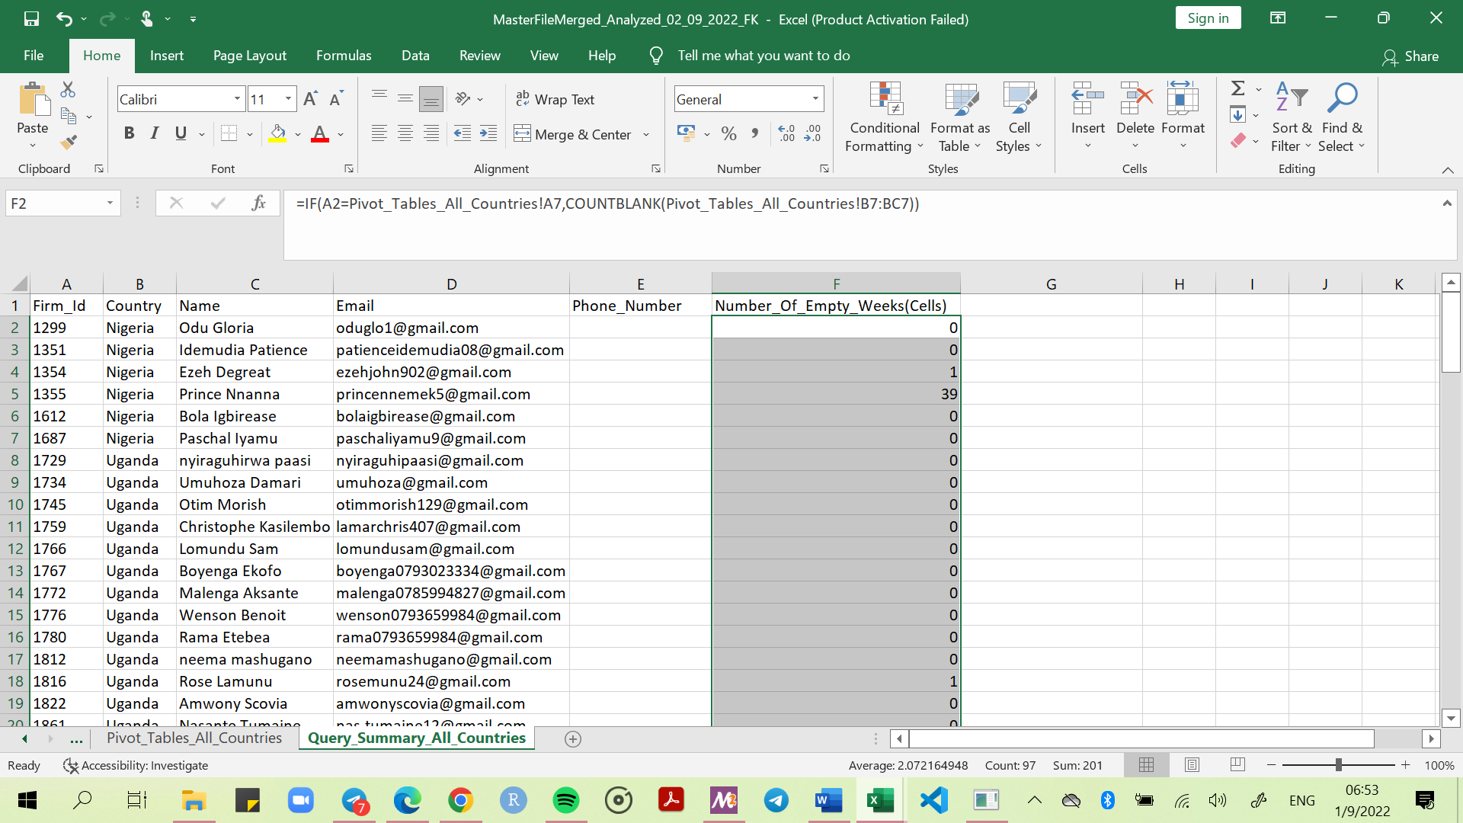

1. Create a new column and name it *Lack Of Data Collection*. Use the **IF** as well as the **AND** formulas as below. Use the fill handle for the rest.

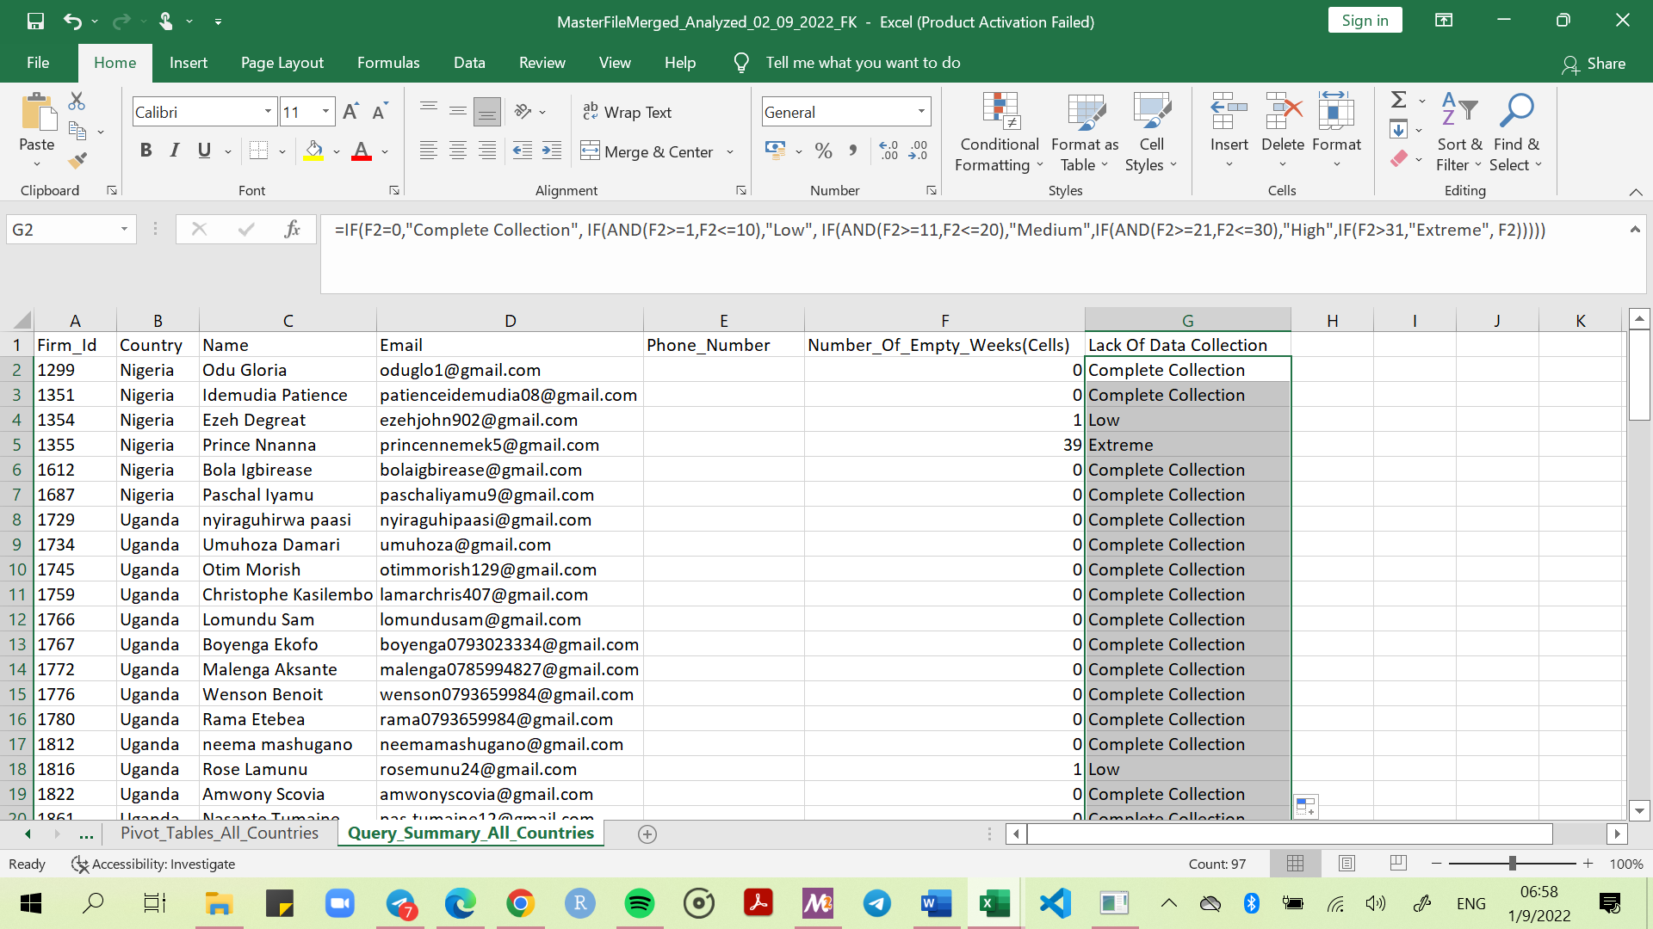

1. Create another column and name it observation. Use the formula below

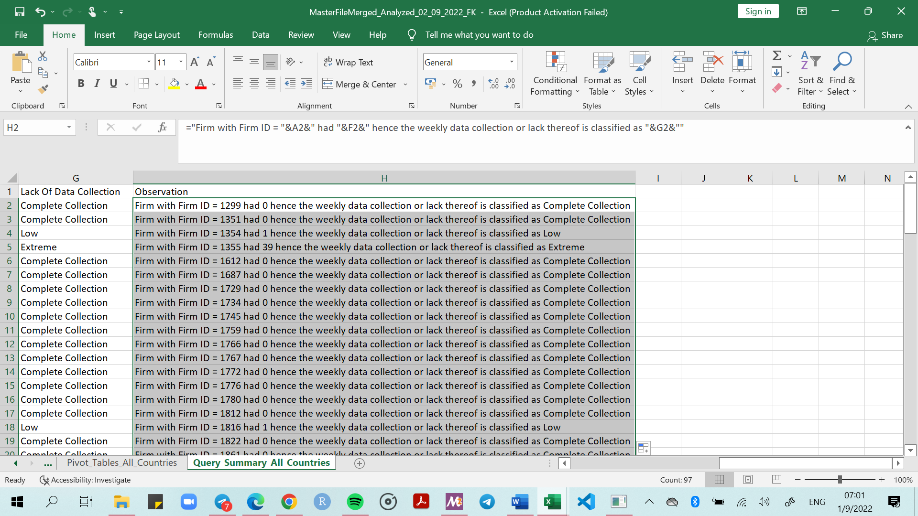

1. Create a column called Resolved. Click the first cell in the column, go to the Menu ribbon, under Data, select Data Validation. Under *Allow*: select *List*. Go down to Source, type the text or numbers (separated by commas, for a comma-delimited list) that you want in your drop-down list, and click OK. See below.

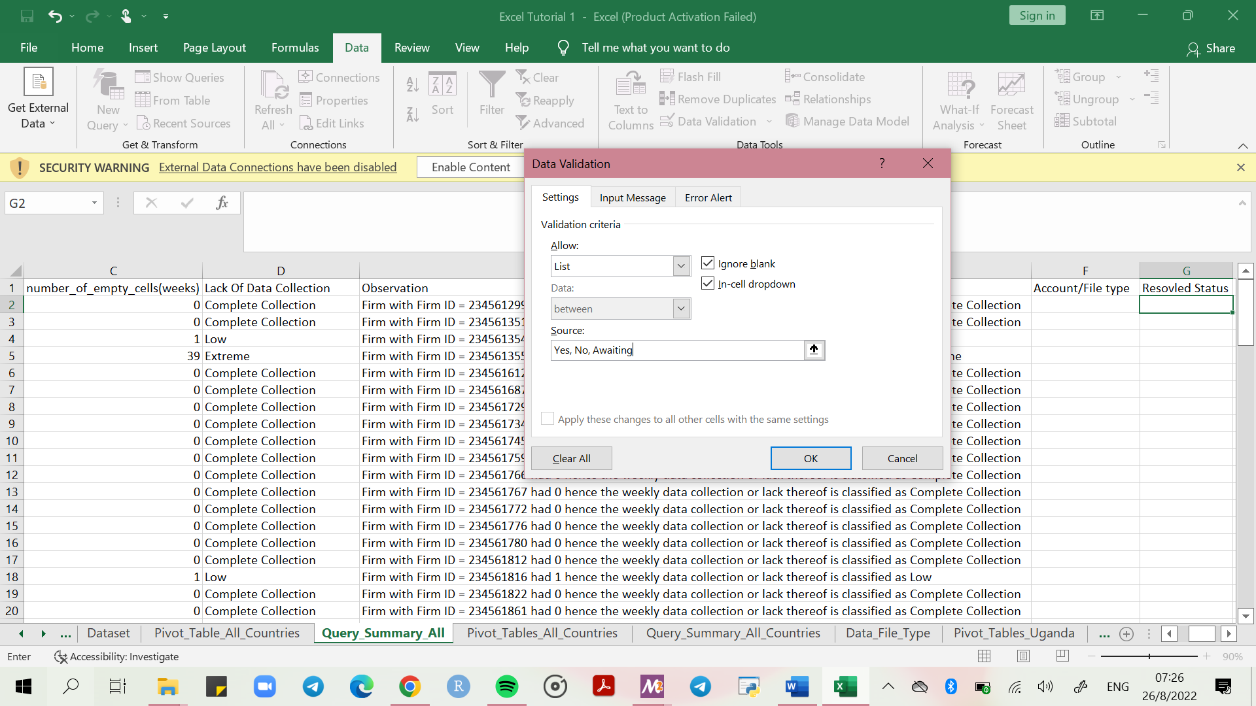

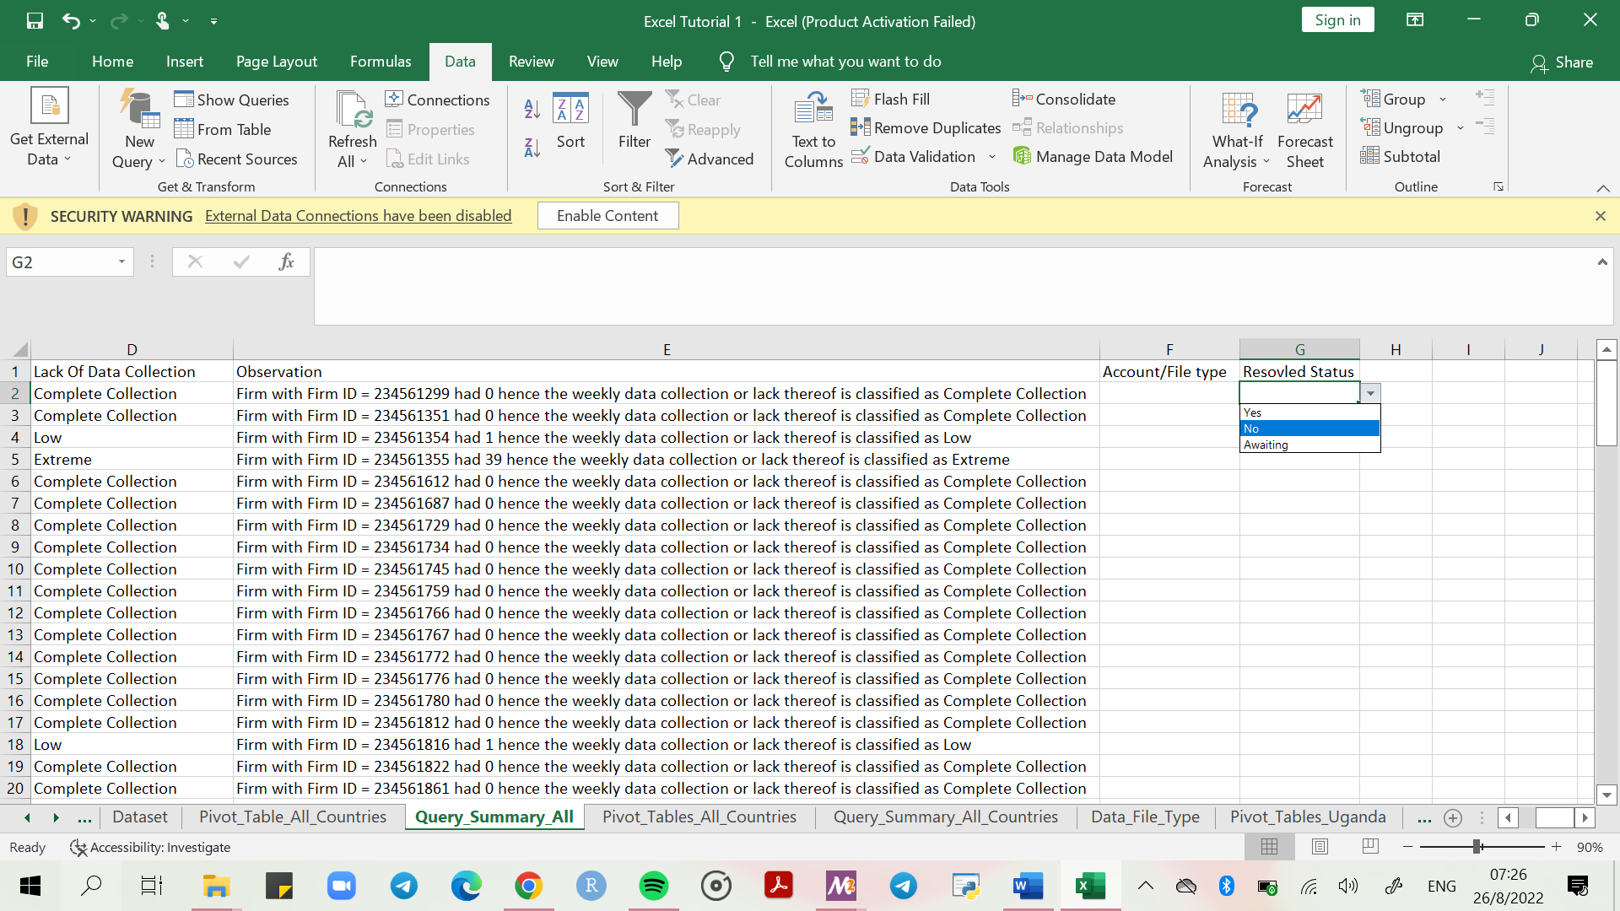 Hover the curser on the downward arrow and select the desired option. For example, Yes, No, Awating.

# Check for Firms Missing In Action Using Pivot Tables

1. Return to the *Data* spreadsheet, highlight all the data, create a pivot table in a new spreadsheet and name the new spreadsheet *Annual_Tracking_All_Countries*
2. Use the following conditions:

* Filters – what you want to filter the data with. **Recommended: *Account, Country***
* Columns – what you want in the columns. **Recommended: *Year***
* Rows – what you want in the rows, using the unique identity number. **Recommended:** ***firm_id***
* Values – what you want calculated. **Recommended: *Amount*** that will show *as* ***Sum of Amount***

1. Make sure that all *Filters* (Account and Country) have the *Select Multiple Items* option. See below.

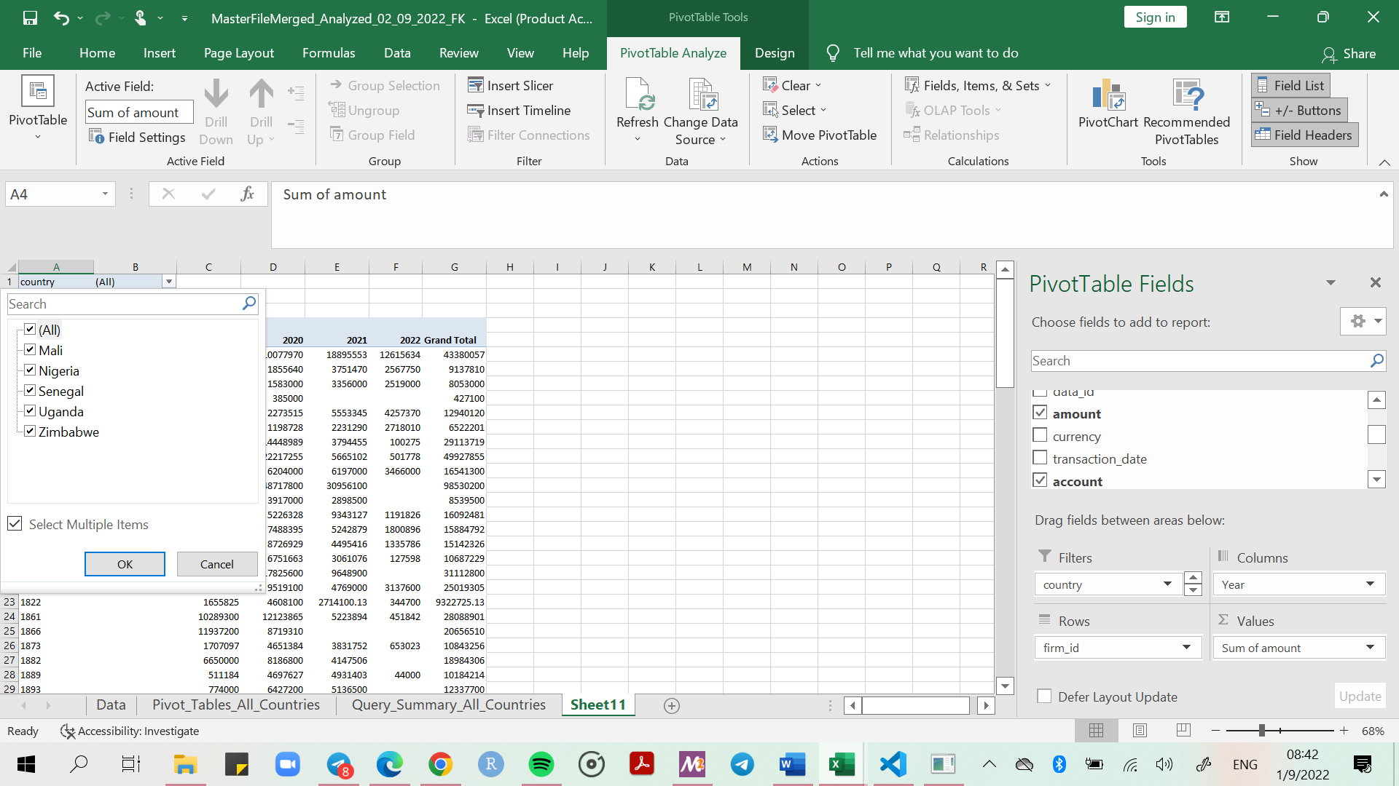

# Final Touches

### Sorting

1. Highlight the first row in the *Query_Summary_All_Countries* spreadsheet.
2. Under the Home ribbon, go to the far-right top corner and select *Sort & Filter*. Select *Filter*.

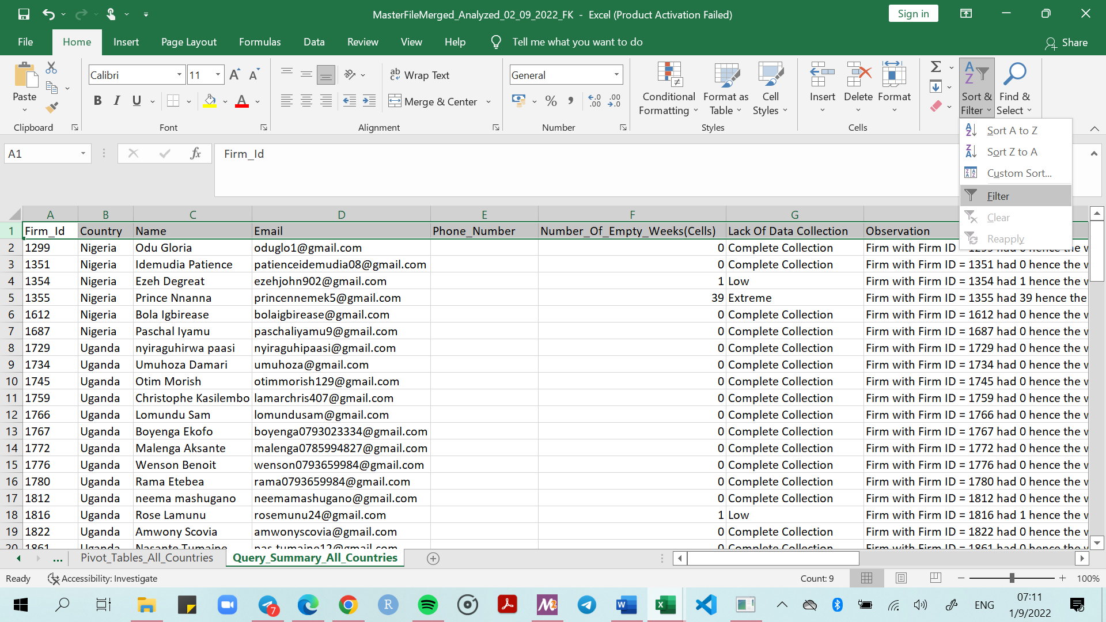

# Export

### Storage

1. Save file *MasterFileMerged_Analyzed_02_09_2022_FK* (correct date, FK = initials of the person analysing the data)
2. Also save as new file: *Cornershop_Output_02_09_2022* (current date)
3. In the *Cornershop_Output_02_09_2022* file, arrange all columns to be of adequate length

### Data Organization & Arranging Using Tables

1. In the *Cornershop_Data_Output_02_09_2022* file, highlight all of the data in the *Query_Summary_All_Countries* spreadsheet, go to the Insert tab, select insert table as below.

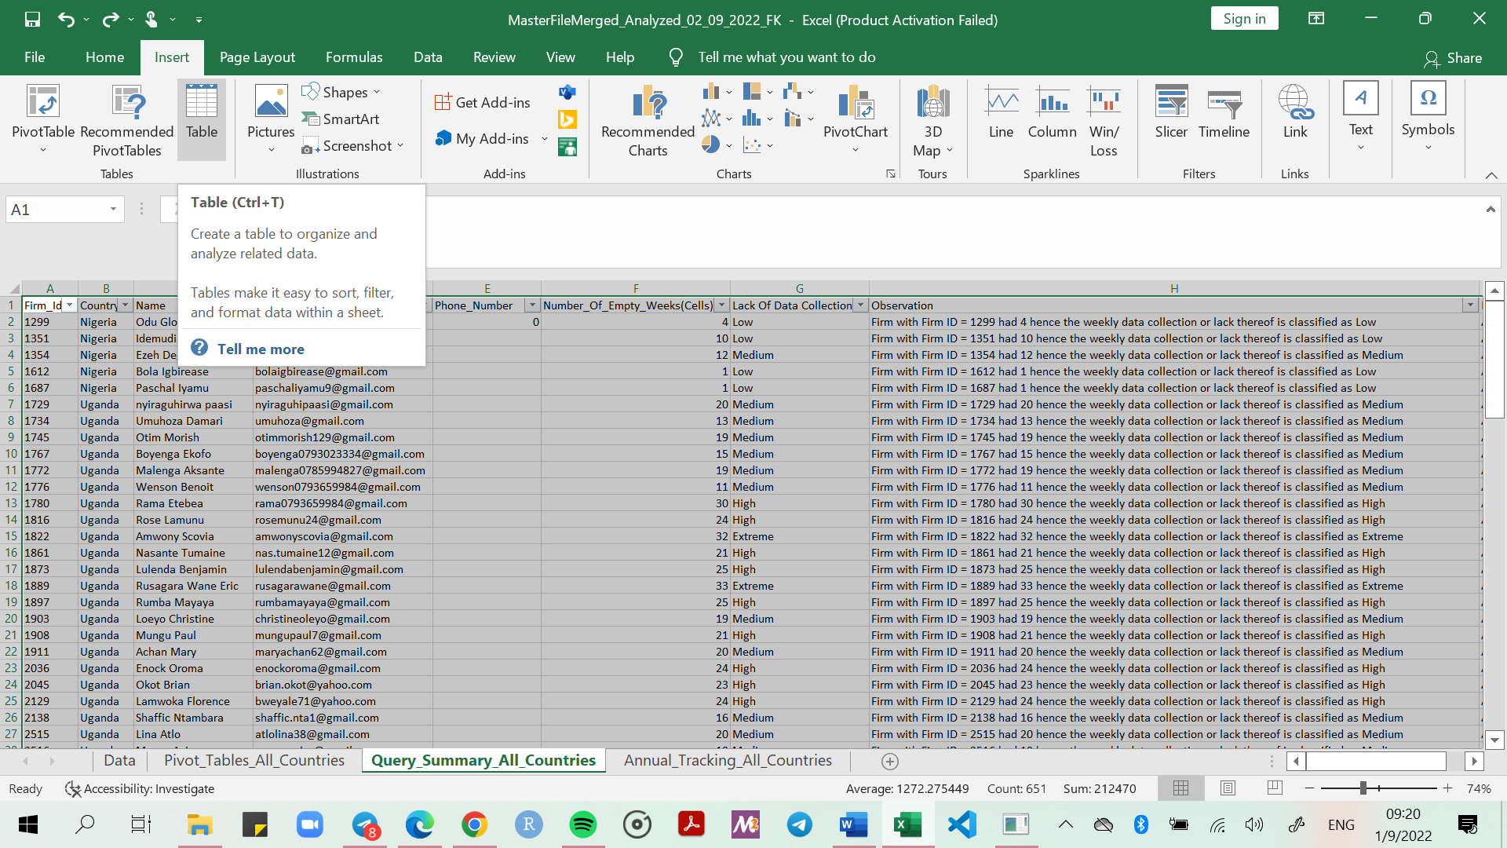

1. Click ok as below.

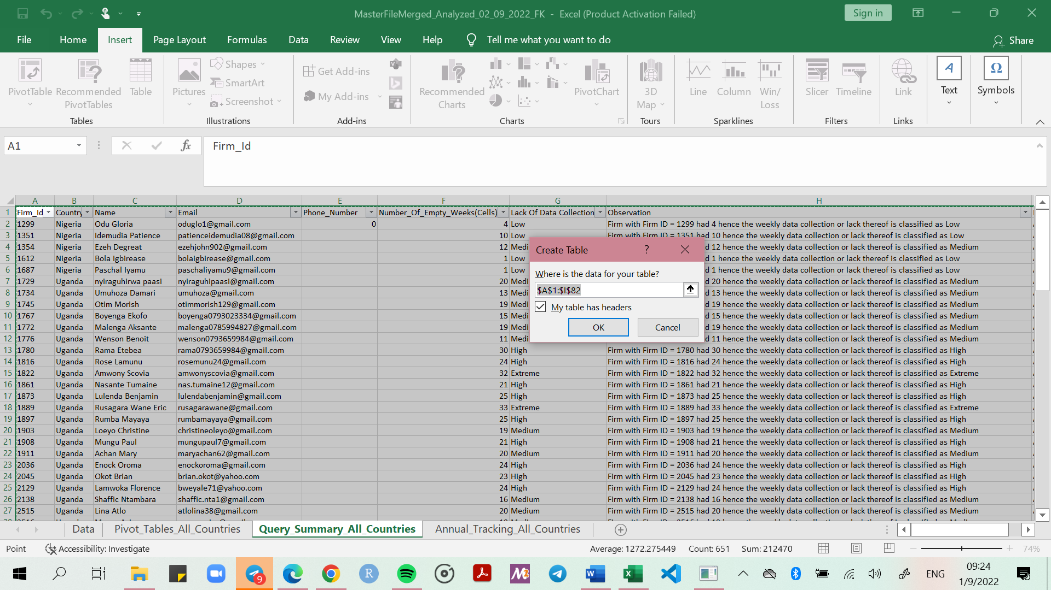

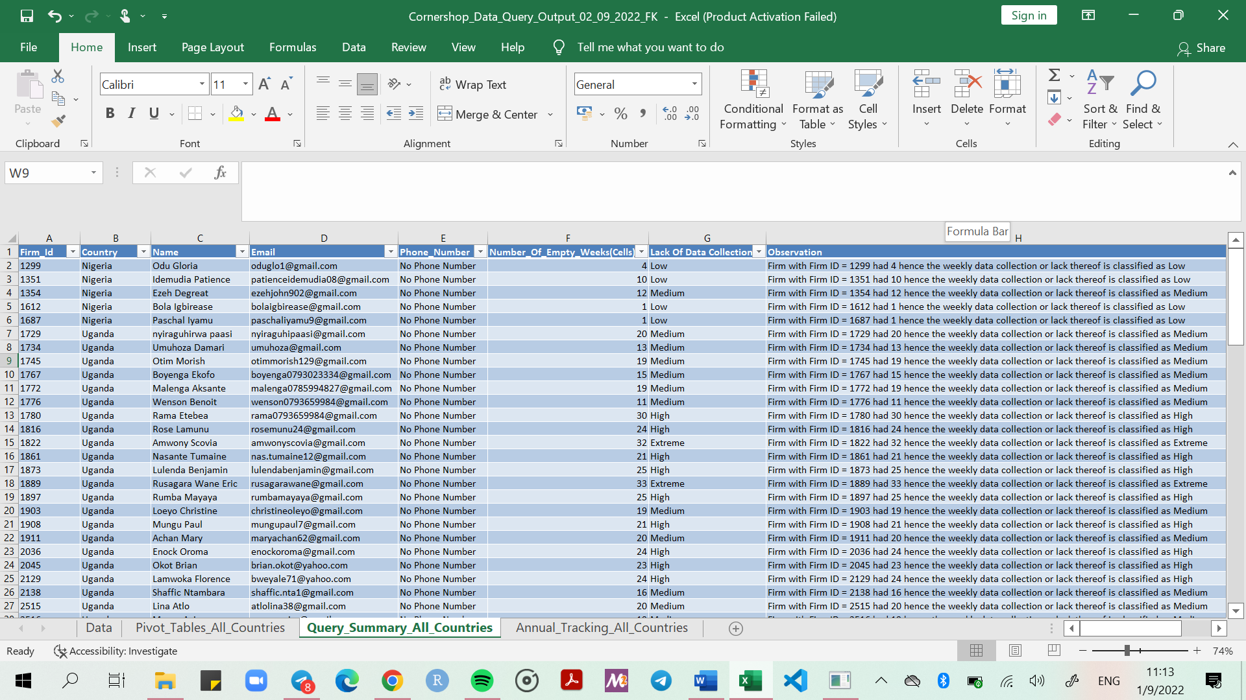

1. Copy and paste **as values** all contents in ***Firm_id, Country, Name, Email and Phone number*** to avoid errors. Ignore the rest.

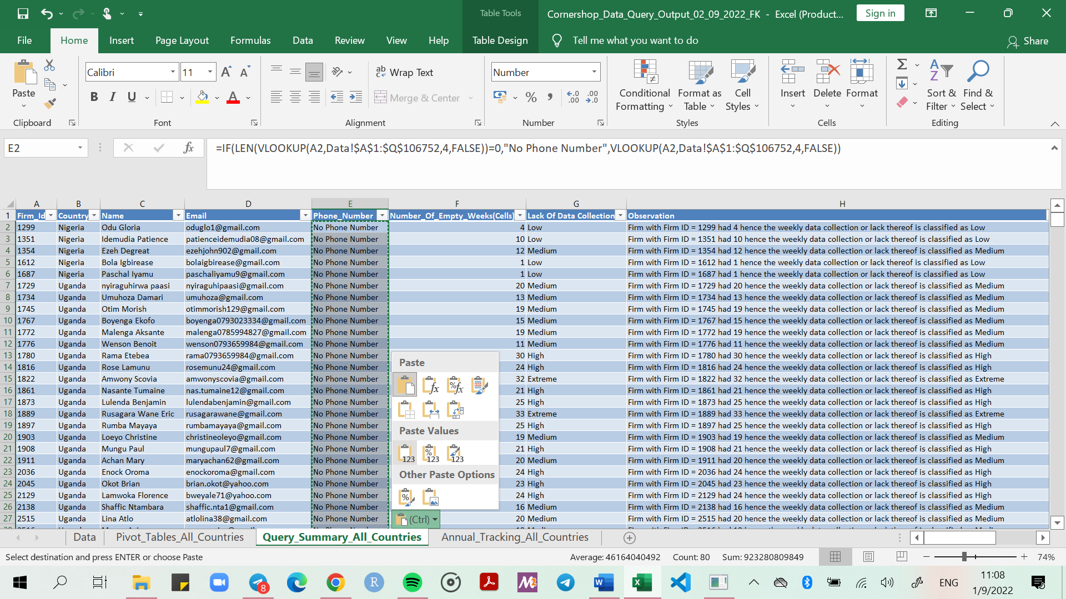

1. Send out file